PERTH AND SMITHS FALLS DISTRICT HOSPITAL
POLICY AND PROCEDURE
TITLE: How to View a Document in Medworxx PDMS
CREATION DATE: 2017-12-14
AUTHOR: Kimberly Kehoe
Purpose:
To provide standardized instructions for locating controlled documents within the Medworxx Document Management System (PDMS), ensuring staff access the most current and approved versions in compliance with accreditation standards.

Policy Statement:
The Medworxx Policy and Document Management System, referred to as PDMS is an electronic system that is used to track, manage and store documents reducing the amount of paper and ensures that the most current version is available for use.

Definitions:
Controlled Document is a document that is the controlled from creation to archive. It is considered the most current version and is often the electronic version.

Uncontrolled Document – an uncontrolled document is a document that is copied and distributed in paper format. Uncontrolled documents should always be verified against the electronic version to ensure that the most current version is used.

Procedure:
- Select the short cut for Medworxx – PDMS from the Staff Education shared drive.
- Select the Staff Education folder on the computer desktop.
- Select 001_Staff Education folder fro the displayed list
- Select the All Staff folder from the displayed list
- Locate and select the shortcut for Medworxx-PDMS
Note: You can also enter PDMS.psfdh.on.ca in your internet browser.

- You do not need to sign in to view documents.

- Locate and click on the Search tab located at the top of the screen.

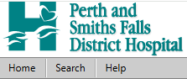

- The Search dialog box displays. You may search by Keyword or you can search by category.

- Keyword Search
- Keywords – enter a keyword that will assist you in locating the correct document. The system will search for content items and returns them, if the keyword(s) entered are in the following fields.
  - Title (Name of Document displaying in PDMS)
  - Description
  - Other Detail fields
  - Document body
- Select Partial
- Name – this is optional.
- Click on the Search icon

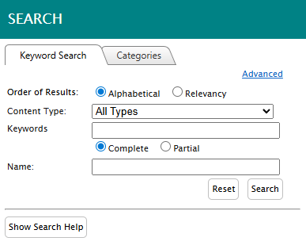
- A list of documents meeting the criteria that you entered will be displayed. If a description has been entered when the document was imported, additional information will be displayed summarizing the purpose/details of the document that may assist with selection of the most appropriate document.

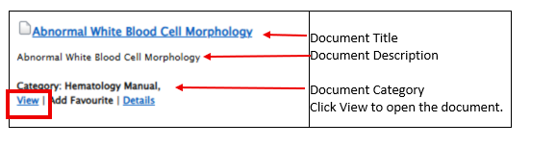
Click on VIEW and the document will be downloaded to the computer. The document will be displayed as a PDF document. The document may be printed by selecting the computer icon located in the top right corner. All printed documents should be discarded after use.

Procedural Notes:
- If you are unable to locate your document, at “Content Type”, select “all types” and try searching once more.

- If you search under “categories”, it is important to note that the document is filed under the document owner. Documents can only be filed under one location/category, and this is to ensure that the document is adequately controlled. For example, a procedure for collecting Newborn Screen is filed under Laboratory since it is a laboratory test.

Revision History
2017-01-05 New
2017-12-14 Add Procedural Notes
2026-04-28 Add Screen Shots

